Graphene-metal oxide composite film laminated to carbon fiber interior for lightweight 50 MHz RF isolation
Cross-domain
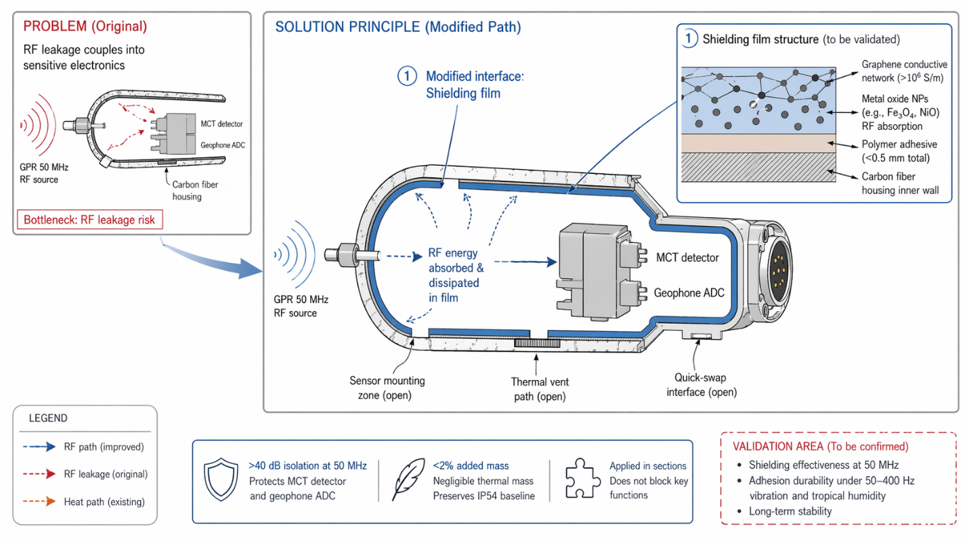
Laminate a thin graphene-metal oxide composite film (<0.5 mm, mass <0.2 kg) to the interior surface of the existing carbon fiber housing using a polymer adhesive. The graphene framework forms a high-conductivity conductive network (>10^6 S/m), while anchored metal oxide nanoparticles (e.g., Fe₃O₄, NiO) absorb 50 MHz RF energy from the GPR, achieving >40 dB isolation to protect the MCT detector and geophone ADC.
The film is applied in sections to avoid obstructing sensor mounting zones, thermal venting paths, and the quick-swap interface. It adds <2% to the pod's total mass and negligible thermal mass, preserving the IP54 thermal management baseline.
Shielding effectiveness at 50 MHz and adhesion durability under 50–400 Hz vibration and tropical humidity require prototype testing to confirm long-term stability.
View details
Reference
Lightweight electromagnetic shielding tarpaulin and preparation method thereof
Substance-field analysis
Composite materials

